**Name:- Chaudhari Girish Ravindra**

**Class:- MCA-I(A) Roll no:-11 Sub:- DBMS**

# 1. Revising Aggregations - The Sum Function

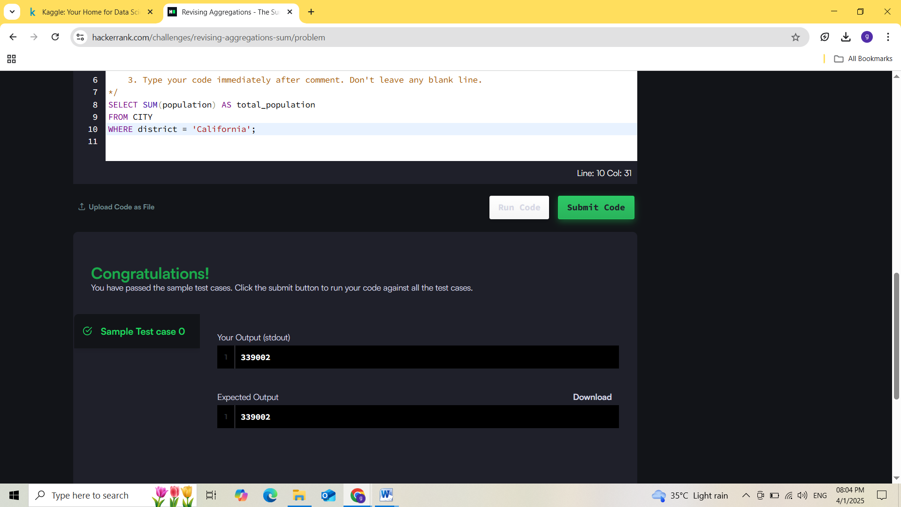

**2. Weather Observation Station 2**

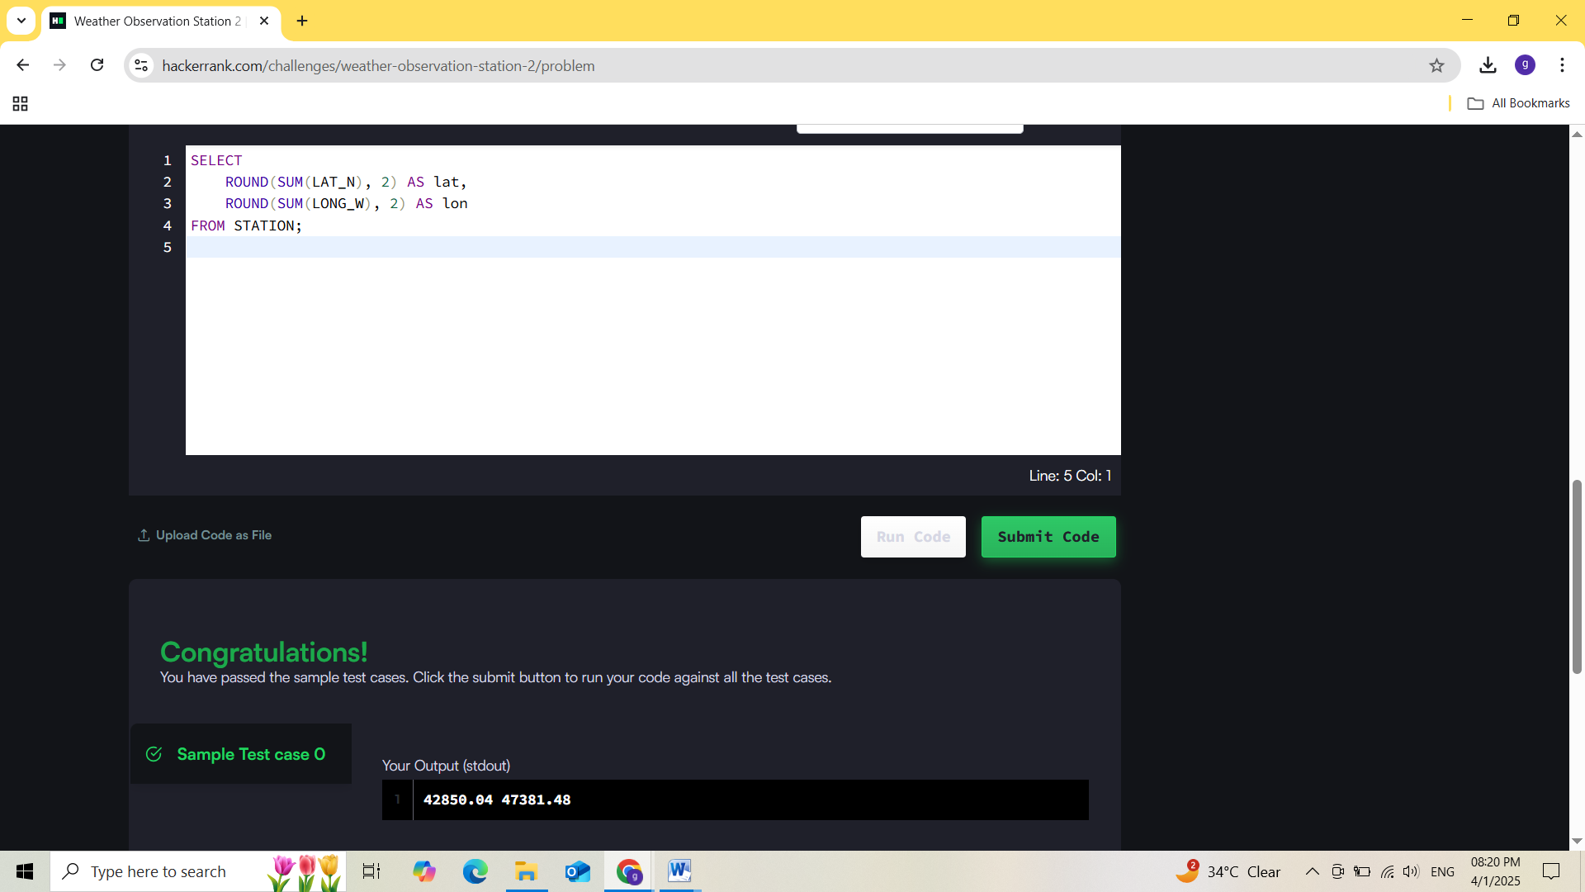

**3. Revising Aggregations - The Count Function**



**4. Weather Observation Station 20**



**5. Min and max spend**

